Web Engineering   
Assignment#1  
Urooj Ayub  
04456  
BESE-4B

**Link to Public Repository - https://github.com/UroojAyub/Alphabets.git**

# Description

There were three main components in this assignment.  
Home Page

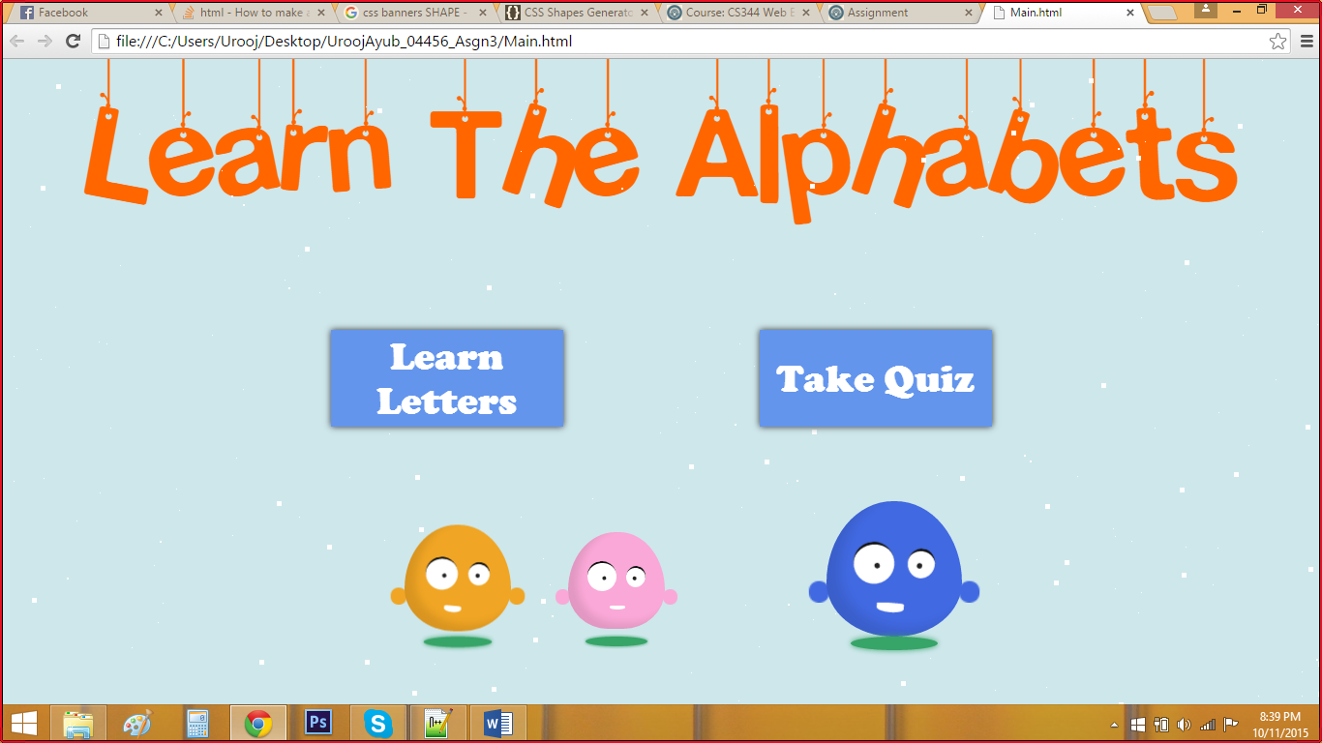

The home screen consists of two buttons directing to the “learn letters” page and the “quiz” page.

A lot of CSS in this page was taken from codepen.io

## Learn Letters Page

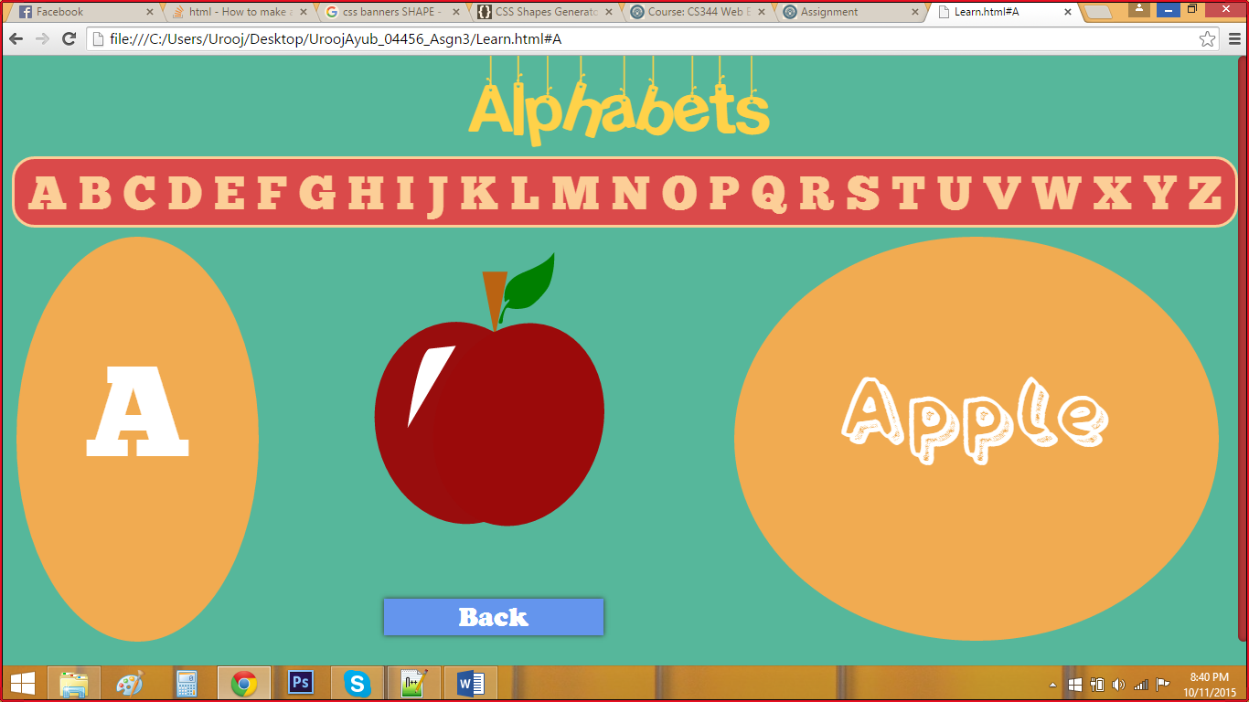

It consists of a slider where you can choose the letter and on clicking it the corresponding word and picture popsup. There is also back button.

## Quiz Page

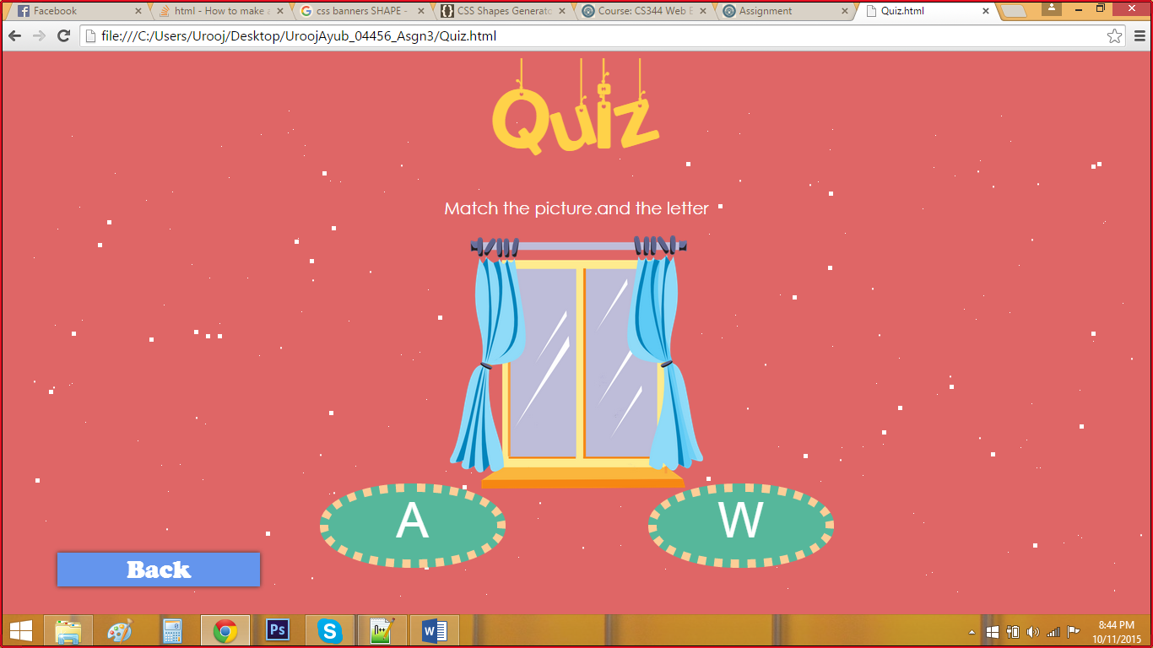

It shows a quiz where the screen displays a picture and the user has to select the letter with which the object in the picture starts. On successful completion of the quiz the following screen is displayed.

